INTEGRATION REPORT

TESTCASE 1: (Authentication)

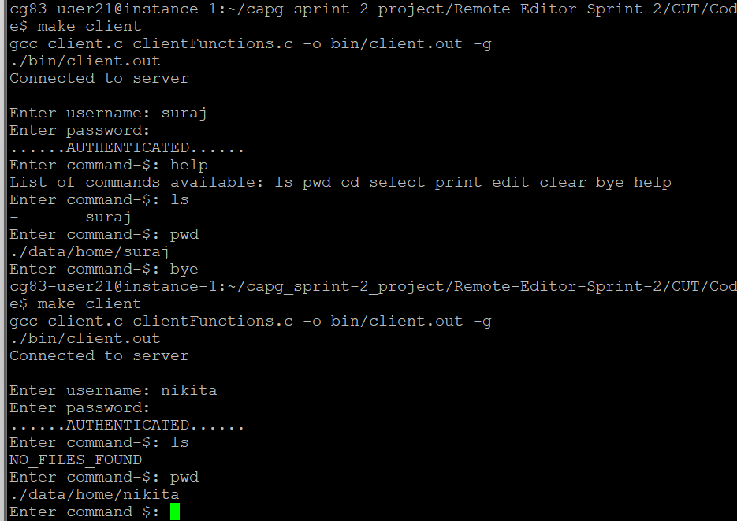

TESTCASE 2: (Anonymous user)

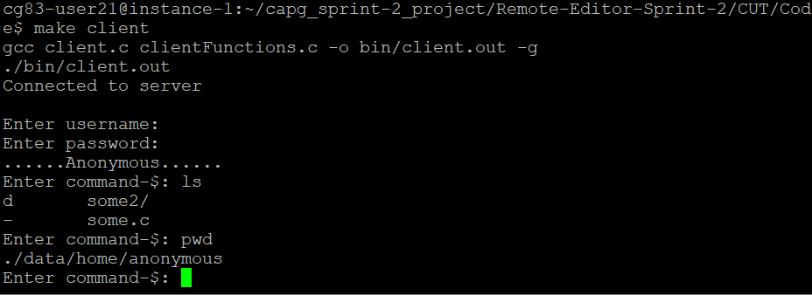

TESTCASE 3: (cd and pwd command)

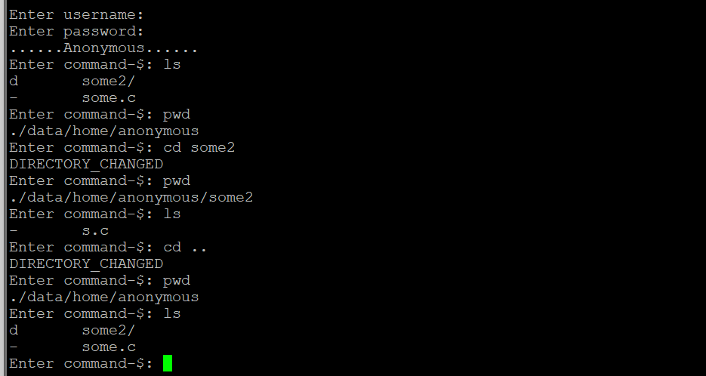

TESTCASE 4: (print command)

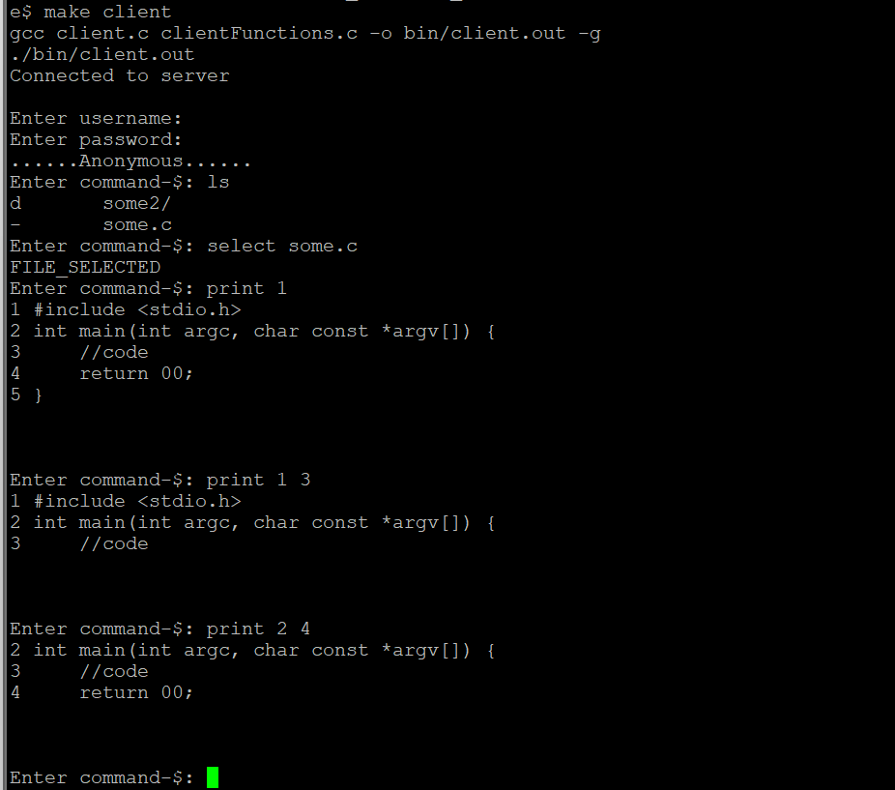

TESTCASE 5: (edit command and invalid line number)

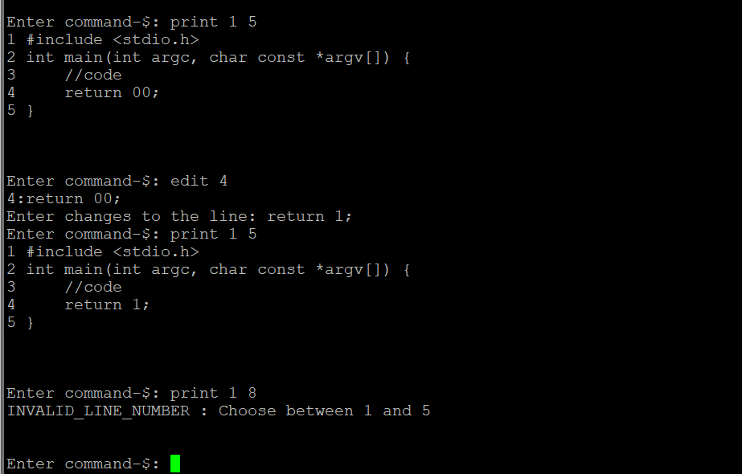

TESTCASE 6: ( bye command)

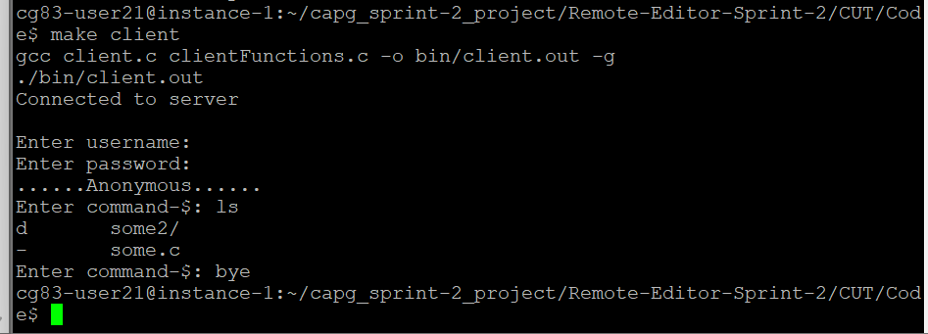

TESTCASE 7: (help command and invalid command)

